Арканникова Елена Владимировна, МБОУ СОШ № 10, Белокалитвинский район, п.Горняцкий.

The Great Patriotic War. Vasily Vasilyevich Svinarev.
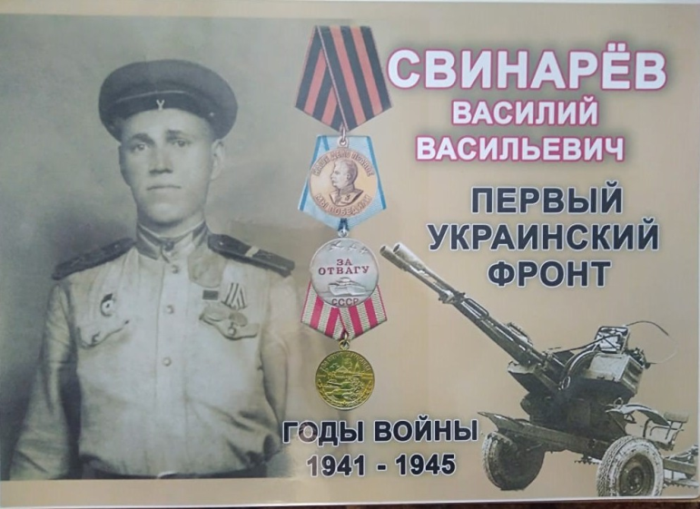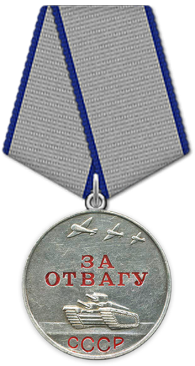

The Great Patriotic War is a terrible page in the history of our country. Eighty years have passed since the Victory in the Great Patriotic War, but it still finds reflection in human souls. This Victory was achieved with great effort. Every family in the country was touched and involved into this cruel war. Even my great-grandfather participated in it. His name is Vasily Vasilyevich Svinarev, he was born in Lenin farm on February 10, 1922. He was called up for service in 1941 in the Litvinov farm and received the rank of Guard corporal. After taking the oath, my great-grandfather went to the first Ukrainian front, where he took an active part in the fighting. He was a tube reader of the first Guards Separate Anti-Aircraft Artillery Battery. He did not receive a single injury during the entire war.
From the document about the great-grandfather's feat:
"Since June 22, 1941, Comrade Svinarev has been at the front of the Patriotic War. In battles, he repeatedly showed a model of courage and bravery.
So, for example: 02.11.43 during the raid of 20 enemy aircraft on the battery, despite the explosion of bombs on the battery, Comrade Svinarev did not lose his head and continued to calmly read the tube until the raid was reflected. "
List of his awards: 1) 30.11.1943 Medal "For Bravery"
2) 01.05.1944 Medal "For the Defense of Moscow"
3) 09.05.1945 Medal "For the Victory over Germany in the Great Patriotic War of 1941-1945"
From the stories of the Brovchenko family:
My dad often asked my great-grandfather about the war. My great-grandfather did not like to talk about this topic and talked only about how he shot down fascist planes, and how many of them were on his account. But when Dad wanted to know more, he couldn't stand it and just cried, remembering that terrible time. And this is not surprising, because it is morally difficult to open such a wound. My great-grandfather died at the age of 79. My great-grandfather was one of those million soldiers who fought against fascism and won the battle. I'm proud of my great-grandfather.
Vocabulary:
the oath – присяга, клятва
the first Guards Separate Anti-Aircraft Artillery Battery - первая гвардейская отдельная зенитная артиллерийская батарея
the injury – рана, ранение
сomrade – товарищ
the raid – налёт, облава
Задания:
- Заполните информацию о герое текста.
Fill out a fact file about the Hero.
Name: _________________________
Date of birth: ____________________
Place of birth: ____________________
Military rank: _____________________
Feat: ____________________________
Rewards: __________________________
Date of death: _____________________

- Определите, какие из приведённых утверждений соответствуют содержанию текста (1 – True), какие не соответствуют (2 – False) и о чём в тексте не сказано (3-Not Stated)
Say which of the following facts are true, false or not stated in the text.

1. In many families there are people who took part in the fighting.
2.Vasily Svinarev was born in a pleasant family.
3.He attained the rank of Guard corporal.
4. Vasily Svinarev ended up on the second Ukrainian front, where he took an active part in the fighting.
5.He showed an example of boldness in the fighting.
6.After the war he worked as a driver.

- Вырази свое мнение по теме:
What is your opinion on the next question?

- Do you think it is important to remember what soldiers of the Great Patriotic War did for us? Why?

Эталоны ответов:
1. Заполните информацию о герое текста.
Name: Vasily Vasilyevich Svinarev
Date of birth: on February 10, 1922
Place of birth: in Lenin farm
Military rank: the rank of Guard corporal
Feat: during the raid of enemy, he continued to calmly read the tube
Rewards: Medal "For Bravery", Medal "For the Defense of Moscow", Medal "For the Victory over Germany in the Great Patriotic War of 1941-1945"
Age of death: 79

2. Определите, какие из приведённых утверждений соответствуют содержанию текста (1 – True), какие не соответствуют (2 – False) и о чём в тексте не сказано (3- Not Stated)

1. In every family there are people who took part in the fighting. True
2.Vasily Svinarev was born in a pleasant family. Not Stated
3.He attained the rank of Guard corporal. True
4. Vasily Svinarev ended up on the second Ukrainian front, where he took an active part in the fighting. False
5.He showed an example of boldness in the fighting. True
6.After the war he worked as a driver. Not Stated

3. Вырази свое мнение по теме:
1. Do you think it is important to remember what soldiers of the Great Patriotic War did for us? Why?
I think it is important to remember what soldiers of the Great Patriotic War did for us because this is heroic example of military courage can inspire many defenders of our country to show unprecedented heroism in all the trials that befell the country.

