Быкадорова Елена Олеговна, учитель английского языка, МБОУ ООШ №4,
Since 14 October 2022, Vladislav has been mobilised as a driver for the support platoon of a tank battalion. He is an active participant of combat operations to the present day. He was awarded with certificates and medals: "To the participant of special military operation", "For strengthening combat friendship", "For bravery". The participant of the special operation is eagerly loved and waited for by his family. Grinko Vladislav is the pride of our school.

Белокалитвинский район, п. Синегорский

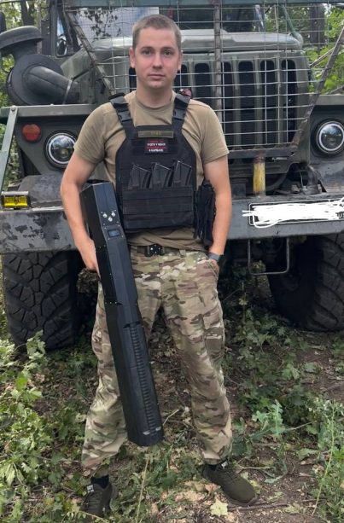
The pride of our school.

Every day our servicemen, risking their lives on the front line, ensure the security of the country.
One of such brave fighters is our fellow countryman and former graduate of our school MBOU OOSH No. 4, Vladislav Olegovich Grinko. He was born on 27 August 1998 in the town of Belaya Kalitva, Rostov region.
In 2005 he entered the first grade. As a student at school, he led an active life, participated in school competitions and Olympiads, and took part in sports.
In 2014, I entered Belokalitvinsky multiprofile technical school as an electrician for repair and maintenance of electrical equipment. He took part in the 4th All-Russian Olympiad "Thinker" in mathematics and won 3rd place. Then in 2016 I took a programme of professional training for drivers of vehicles of category "B"
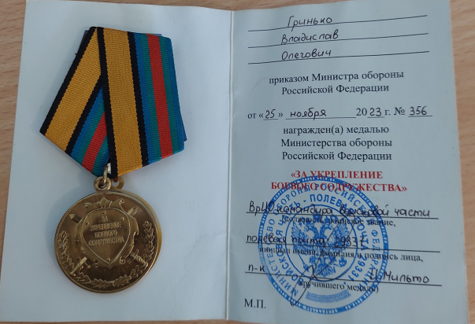
In October 2017, Vladislav was called up for compulsory military service as a military driver. After being discharged, he got a job at Sadkinskaya Mine Department, as an electrician.
In 2021 he entered "Platov South Russian State Polytechnic University named after M.I. Platov at the faculty of "geology, mining and oil and gas business". In his free time Vladislav likes to do car sound installation.
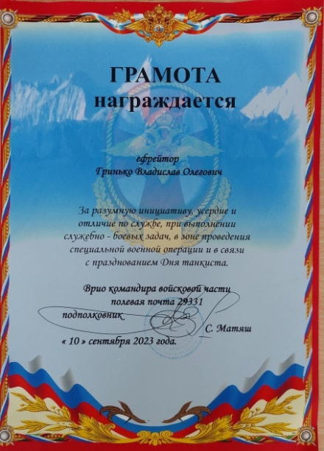
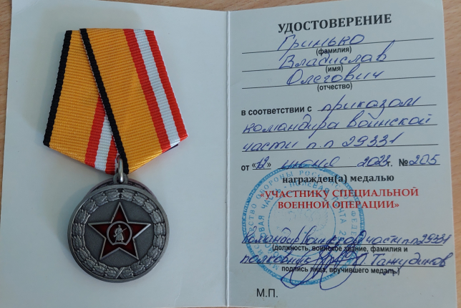
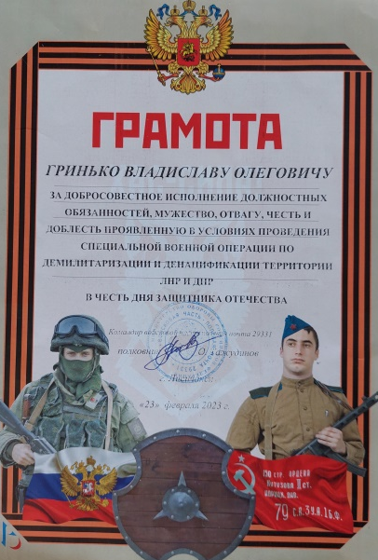
Since 14 October 2022, Vladislav has been mobilised as a driver for the support platoon of a tank battalion. He is an active participant of combat operations to the present day. He was awarded with certificates and medals: "To the participant of special military operation", "For strengthening combat friendship", "For bravery". The participant of the special operation is eagerly loved and waited for by his family. Grinko Vladislav is the pride of our school.

Tasks for the text. Задания к тексту.
- Which of the following factors are true (T), false (F), not in the text (NT). Какие из следующих факторов верные (T), ложь (F), нет в тексте (NT)
- Vladislav participated in the IV All-Russian Olympiad "Thinker" in the subject of mathematics, took 3rd place.
- Vladislav didn't go to university.
- The Kalitva River flows in the town of Belaya Kalitva.
- Vladyslaw was mobilised as a pilot in the air and space forces
- Vladislav was mobilised as a driver for a tank battalion support platoon.
1) | 2) | 3) | 4) | 5)
- Choose the correct answer to the questions based on the text. Выбери правильный вариант ответа на вопросы, опираясь на текст.
- What year did Vlad go to school?
a)1998 b) 2005 c) 2014
- What was Vladislav's job before mobilisation?
a)driver b) electrician c) salesman
- Favourite hobby in free time
a)car repair b) car sound installation c) car painting
- How many medals did the special operation participant receive?
a)2 b) 3 c) 4
1) | 2) | 3) | 4)
- Relate the dates to the events. Соотнеси даты с событиями.
- 1998 | - He was mobilised to the SMO area
- 2005 | - Went to university
- 2014 | - was trained in a professional driver training programme
- 2021 | - was called up for compulsory service
- 2022 | - went to technical school
- 2017 | - year of birth
- 2016 | - went to school
1) | 2) | 3) | 4) | 5) | 6) | 7)

- Write a letter to the soldiers involved in a special military operation. Напиши письмо солдатам, участвующим в специальной военной операции.
____________________________________________________________________________________________________________________________________________________________________________________________________________________________________________________________________________________________________________________

Ansvers to tasks. Ответы к заданиям.

1) T | 2) F | 3) NT | 4) F | 5) T

1) b) | 2) b) | 3) b) | 4) b)

1) f) | 2) g) | 3) e) | 4) b) | 5) a) | 6) d) | 7) c)

Hello, soldiers! I'm writing you a letter in which I want to say "THANK YOU"! Thank you for sacrificing your lives to save ours! Thank you for serving and defending our Motherland! I wish you all to be invincible and brave! Know that you are welcome at home! They believe in you!

